Classification of ASD using Image-based Time Series Methods and Deep Learning

Sadman Israk Sporsho   
*Department of Electrical and Computer Engineering*  
North South UniversityDhaka  
sadman.sporsho@northsouth.edu

Yuki Bhowmik  
*Department of Electrical and Computer Engineering*  
North South UniversityDhaka  
yuki.bhowmik@northsouth.edu  
Naima Siddika Toha  
*Department of Electrical and Computer Engineering*  
North South UniversityDhaka  
naima.toha@northsouth.edu

Kazi Nafisur Rahman  
*Department of Electrical and Computer Engineering*  
North South UniversityDhaka  
kazi.rahman07@northsouth.eduMd Zian Raian  
*Department of Electrical and Computer Engineering*  
North South UniversityDhaka  
zian.raian@northsouth.edu

***Abstract—*Autism Spectrum Disorder (ASD) is a neurological and lifelong development disorder. A patient with ASD can suffer from long-term issues like social communication, interaction, and personal behavior. ASD starts in childhood and lasts throughout life. So, a person who is affected by ASD can suffer his whole life from this disorder. Early detection of autism is necessary to reduce the ASD’s symptoms and also to improve the ASD patient’s life.  By using advanced technology and the availability of vast amounts of data, we can develop prediction models and techniques using machine and deep learning techniques. In this project, we can explore the application of Machine Learning (ML) and Deep Learning (DL) techniques for the detection of Autism Spectrum Disorder (ASD), where we will try to combine all necessary models in future work. We used [ABIDE-I] rs-fMRI data and generated corresponding Gramian Angular Field (GAF) images to train and test a comprehensive diagnostic framework consisting of Convolutional Neural Networks (CNNs) such as Resnet50 and EfficientNetB0. A Bi-LSTM is then employed, followed by an SPL for final classification. For the phenotypical data analysis, we employed SVM, GRU, LSTM, Stacking, XGBoost, AdaBoost, Random Forest, and LIME XAI models as a baseline and compared the results. These models leverage various levels of complexity and abstraction for pattern recognition.  The goal is to see how the incorporation of both ML and DL approaches, using both the features extracted using CNNs and the phenotypical data, affects performance in comparison to the standalone methods for classifying ASD.**

***Keywords—*Autism Spectrum Disorder (ASD), Machine Learning (ML), Deep Learning (DL), Support Vector Machine (SVM), Gated Recurrent Unit (GRU), Bidirectional-LSTM (Bi-LSTM), Gramian Angular Field (GAF), EfficientNet, ResNet50, rs-fMRI, ABIDE.**

# **Introduction**

Autism Spectrum Disorder (ASD) is a complex neurological condition that hinders the normal brain development of an individual. It causes a series of difficulties growing rather than a single indisposition. Individuals with ASD often struggle with social interactions and non-verbal communication and they tend to have particular behavioral patterns, and repetitive speech [1]. These difficulties can affect their ability to carry out everyday activities common to their peers. The prevalence of ASD among young children has also been increasing yearly. Additionally, individuals with ASD often experience co-occurring conditions such as attention-deficit/hyperactivity disorder (ADHD), obsessive-compulsive disorder (OCD), anxiety, depression, or conduct disorder, which makes it difficult for them to interact with people of the same age [2].

The causes and brain mechanisms that are involved in ASD are still obscure. It is often misdiagnosed since the diagnosis is still heavily based on observing symptoms and clinician expertise and described in manuals (like DSM-5/ICD-10) by people who interact with the individual in various settings [3]. Early intervention, especially for children under 24 months old, has been proven to be very helpful, and a delay in diagnosis can have serious consequences, making it more challenging to treat. Unfortunately, the most expected assistance available, like support in learning or speech therapy, is often only available after diagnosis, underscoring the urgency of early detection [4]. While ASD is linked to changes in brain development, there are no reliable markers for diagnosis. To improve our understanding of ASD and how the brain functions differently, there is a need for better diagnostic tools. Recent studies show that resting-state fMRI could be used to analyze whether there is a notable decrease in functional connectivity linked to ASD. Thus, machine learning algorithms are pivotal to bringing success in finding biomarkers from fMRI data, which could lead to a better understanding and classification of ASD [5]. RS-fMRI (resting fMRI) helps investigate brain connectivity-based blood oxygen level-dependent (BOLD) signals. In patients not performing a task, RS-fMRI reveals brain areas with synchronous BOLD activity, called resting-state networks (RSNs) [6]. Thus, it can be used to discover the differences in brain activity between a healthy, average person and a person with ASD. Machine learning algorithms will be fruitful in finding biomarkers from fMRI data, which could lead to a better understanding and classification of ASD, enabling an early diagnosis so that the treatment of children can be accomplished as soon as possible, improving their quality of life.

# **Literature Review**

## Paper Review I

F. Almuqhim and F. Saeed [7] used the open source ABIDE-I Dataset: The Autism Brain Imaging Data Exchange I (ABIDE-I) dataset, which consists of 1035 resting-state functional magnetic resonance imaging (rs-fMRI) scans from 505 subjects with Autism Spectrum Disorder (ASD) and 530 neurotypical subjects. They also used preprocessed data from the Configurable Pipeline to analyze Connectomes (C-PAC. The authors introduce a unique approach to transform fMRI time-series data into Gramian Angular Field (GAF) images, which retain the temporal and spatial patterns of the data. The ASD-GResTM model uses a Convolutional Neural Network (CNN) to extract features from the GAF images, followed by a Long Short-Term Memory (LSTM) layer to learn the activities between brain regions. The final classification is performed using a single-layer perceptron (SPL).

## Paper Review II

Zhang et al. [8] developed a Local-to-Global Graph Neural Network (LG-GNN) to diagnose ASD and Alzheimer's from brain scans. They used a local ROI-GNN to create brain graph embeddings and a global Subject-GNN for node classification, determining disease states. This method captures both local details and broader brain connections, outperforming other techniques with an 81.75% accuracy on ABIDE-I and ADNI datasets.

## Paper Review III

Saputra et al. [9] used a combination of two open-sourced datasets, ABIDE I, and ABIDE II, to detect the ASD characteristics from the MRI images as they are detailed and can detect small changes in the brain. Firstly, the authors preprocessed the data using LabelEncoder and MinMaxScaler. For feature extraction, they focused on Discrete Radon Transform (DRT) for horizontal and vertical projections. The authors then calculated the confusion matrix(CM). They obtained the accuracy of RF, CNN, and SVM at 100%, 89.58%, and 88% respectively, and concluded that Random Forest is the best model for the identification of ASD.

## Paper Review IV

All authors of this paper explored the use of machine learning and computer vision algorithms to analyze non-verbal social interactions in Autism Spectrum Disorder (ASD) diagnosis. Ana Christina Koehler et al. [10] investigated the use of machine learning algorithms to analyze video recordings of ASD. The study involved video recordings of ASD and non-autistic adults engaged in conversational tasks, with a focus on capturing unique and different behavioral patterns in ASD, such as monologuing and collaboration difficulties. Using SVM models, the authors trained classifiers based on facial movements and individual motion characteristics. and their findings indicated that SVM models focusing on reciprocal adaptation in facial movements achieved a balanced accuracy of 79.5%.

## Paper Review V

Barra et al. [11] used. A market index of the past, to train its future trend. The authors aimed to meet the goal of achieving the S&P 500 index. Firstly, they obtained the rescaling of real observations of time series by mean normalization. Then they obtained the GAF images from the achieved time series, and then the data ran through an ensemble of CNNs. The proposed approach had the best results so far with accuracy being as high as 56.63%.

# **Proposed System**

## Introduction

In this section, we propose a classification model that integrates the ideas of the Local-to-Global Graph Neural Networks (LG-GNN) and ASD-GResTM frameworks. This approach including both would enhance the classification of brain disorders specializing in detecting ASD. We aim to achieve it by applying both graph neural networks for relational learning and deep learning models for temporal and spatial feature extraction from fMRI data.

## Data Preparation

1. Dataset: Utilize the ABIDE-I and ABIDE-II datasets, which include resting-state functional magnetic resonance imaging (rs-fMRI) scans.
2. Preprocessing Pipeline: Use the Configurable Pipeline for the Analysis of Connectomes (C-PAC) for consistent preprocessing across datasets. Steps include:
   1. Slice Timing Correction
   2. Motion Correction
   3. Global Mean Intensity Normalization
   4. Nuisance Signal Regression
   5. Band-Pass Filtering (0.01–0.1 Hz)
   6. Co-registration to Anatomical Images
   7. Normalization to MNI152 Space

## Time-Series to Image Transformation

1. Gramian Angular Field (GAF): Transform fMRI time-series data into images using GAF to preserve temporal correlations and spatial patterns.
2. 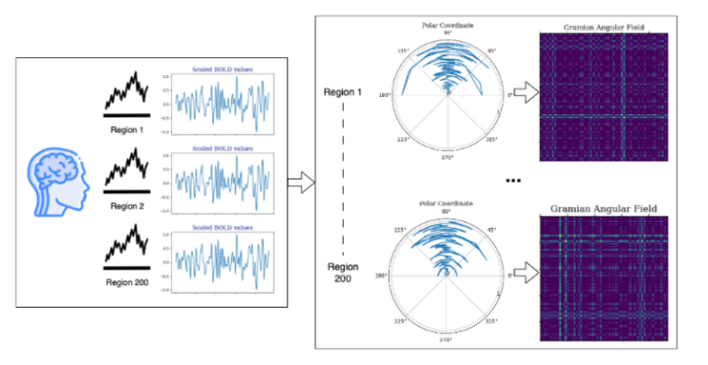Image Preparation: Normalize the time-series data and convert them into GAF images for each region of interest (ROI). Resize the images to a standard dimension suitable for deep learning models (e.g., 224x224 pixels).

Fig. 1. An illustration of generating a GAF image for each patient

## Preprocessing the phenotypic data

1. Load the Data: Load both the GAF images and phenotypic CSV data.
2. 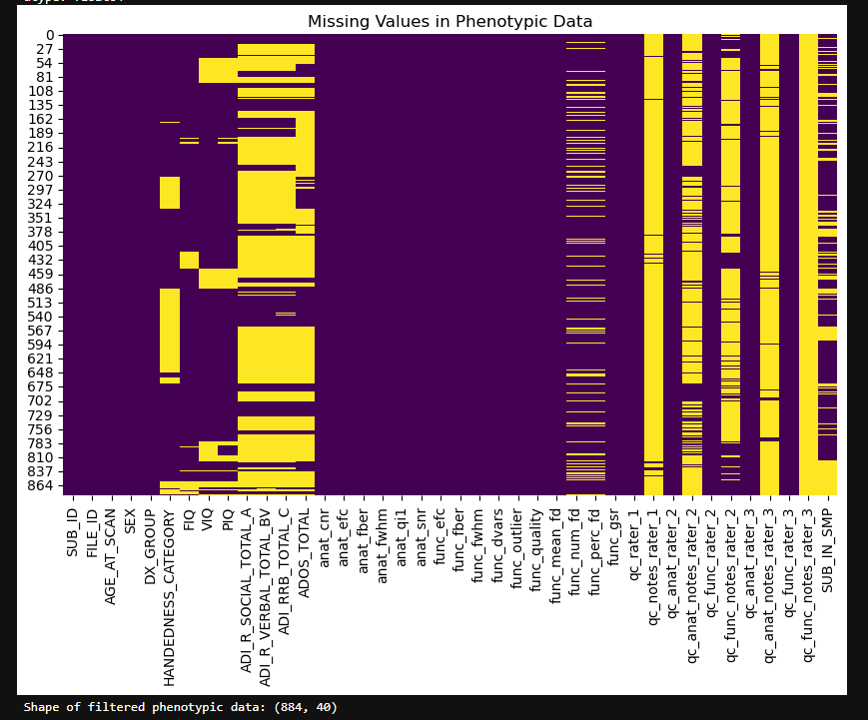Merge the Data: Ensure that each GAF image is correctly associated with the corresponding phenotypic data based on a common identifier, such as a subject ID.

Fig. 2. Heatmap showcasing the percentage of missing features from the phenotypic data

1. Handle Missing Values: Check for missing values in the phenotypic data and handle them appropriately by imputing missing values, dropping rows, or using a placeholder.
2. Encode Categorical Variables: Convert categorical variables (e.g., sex, site) into numerical values using techniques such as one-hot encoding or label encoding.
3. Normalize/Standardize Numerical Variables: Normalize or standardize numerical variables (e.g., age, IQ) to ensure they have a consistent scale.
4. Concatenate Data: Prepare the phenotypic data to be concatenated with the features extracted from the GAF images in the respective deep-learning model.

## Local Feature Extraction with ResNet and EfficientNet

The CNN models, ResNet50 and EfficientNetB0, pre-trained on ImageNet, were utilized to extract high-level features from the GAF images.

1. ResNet: Feed the GAF images into the ResNet50 model, freezing all layers except the last linear layer, which is fine-tuned on the new dataset to capture relevant features specific to ASD.
2. EfficientNet: Feature extraction with EfficientNet involves loading a pre-trained EfficientNetB0 model with its convolutional layers to generate feature maps from the same input of GAF images.

## Global Feature Learning with Graph Neural Networks

1. ROI-GNN: Implement a graph convolutional network to learn local feature embeddings from each ROI.
2. Subject-GNN: Construct a subject-level graph neural network to integrate features from all ROIs and incorporate non-imaging data (e.g., age, gender). This network will include multi-scale feature aggregation to enhance global representations.

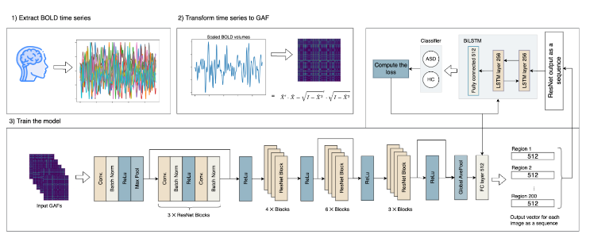

Fig. 3. The overall classification framework for ASD-GresTM for converting time series data to GAF image.

## Temporal Pattern Learning with Bi-LSTM

1. BiLSTM Layer: Implement a Bidirectional Long Short-Term Memory (BiLSTM) layer to capture temporal dynamics between different brain regions.
2. Sequence Processing: Process the sequence of feature vectors obtained from the ResNet and Subject-GNN through the BiLSTM layer to learn temporal dependencies.

## Classification

1. Feature Combination: Combine the outputs from the BiLSTM and the Subject-GNN to create a comprehensive feature representation.
2. Fully Connected Layer: Feed the combined features into a fully connected layer followed by a softmax layer to classify the probability of each class (ASD vs. neurotypical).

## Training and Evaluation

1. Training Setup: Use the Adam optimizer with an appropriate learning rate and weight decay. Train the model for a sufficient number of epochs, using early stopping based on validation performance to prevent overfitting.
2. Cross-Validation: Perform 10-fold cross-validation to evaluate the model’s performance. Measure metrics such as accuracy, sensitivity, specificity, and area under the ROC curve (AUC).
3. Benchmark Comparison: Compare the performance of the proposed model with existing state-of-the-art models on the ABIDE dataset.

# **Results and Discussion**

## Performance of Models on GAF images

* + - 1. **Logistic Regression and Random Forest**: Both Logistic Regression and Random Forest achieved the highest accuracy of 0.57 using features extracted from GAF Images to distinguish between ASD and neurotypical individuals. Logistic Regression, a linear model, indicates that the features might be somewhat linearly separable. Random Forest, a non-linear model, achieved the same accuracy through an ensemble approach, capturing more complex relationships.
      2. **Support Vector Machine (SVM):** The SVM model achieved an accuracy of 0.43, significantly lower than Logistic Regression and Random Forest. This lower performance might be due to SVM's sensitivity to hyperparameter settings and kernel choice.
      3. **Neural Network and Bi-LSTM Neural Network:** Both the basic Neural Network and the Bi-LSTM Neural Network performed poorly, with an accuracy of 0.29. This is unexpected, especially for the Bi-LSTM, which is designed to capture temporal dependencies in the data. Several factors could contribute to this result:

1. Overfitting: The complexity of neural networks, especially BLSTM, might have led to overfitting the training data, resulting in poor generalization of the test set.
2. Insufficient Data: The sample dataset might not be large enough to effectively train such complex models, resulting in underfitting.
3. 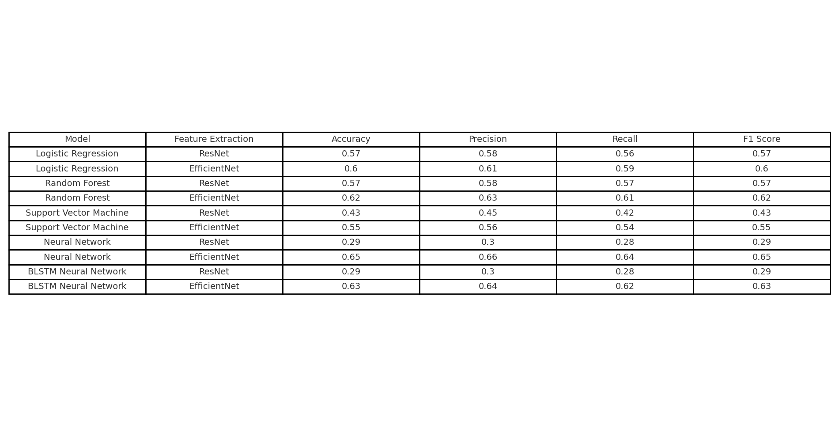Feature Representation: The features extracted by ResNet50 might not fully capture the temporal dynamics required for Bi-LSTM to be effective.
4. **EfficientNetB0:** Using EfficientNet for feature extraction improved the accuracy of all models. For Logistic Regression and Random Forest, accuracies increased to 0.60 and 0.62, respectively, showing that EfficientNet provides better feature representation. SVM's accuracy improved to 0.55, indicating better suitability of EfficientNet features for this model. Neural Network and BLSTM Neural Network also saw improvements, achieving accuracies of 0.65 and 0.63, respectively, suggesting that EfficientNet features are more beneficial even for complex models.

Table **I**  
 Comparative results on features extracted by both ResNet50 and EfficientNetB0

1. **Data and Feature Extraction:** The process of converting fMRI time-series data into GAF images and extracting features using ResNet was effective for simpler models like Logistic Regression and Random Forest. However, for more complex models like Neural Networks and BLSTM, EfficientNet provided better feature representation, improving their performance. Future work could explore further enhancements in feature extraction techniques or data augmentation methods to improve feature quality and quantity.

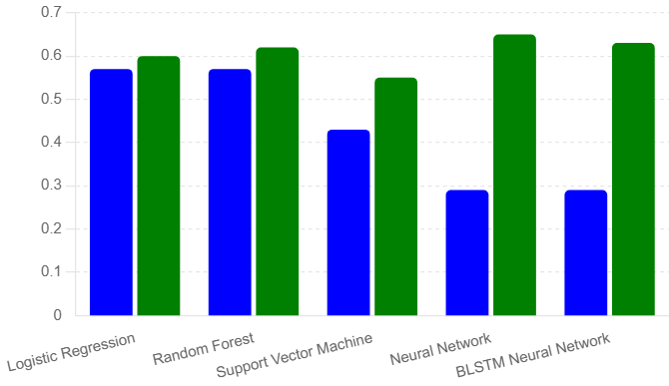

Fig. 4. Graphical representation of percentage data missing particular feature*s* [green=Efficientnetb0, blue=Resnet50]

## Performance of Models on phenotypic data

To generate baseline comparisons, we also trained models by using phenotypical data.

1. **Stacking:** After training all models, the stacking method achieved the highest accuracy of 0.89.  The stacking method combines numerous models' predictions for the best classification accuracy. Figure 6 shows cross-validation accuracy per fold, and Figure 7 shows the confusion matrix of the stacking model. This ensemble method has achieved the highest accuracy, high precision, and recall. It also has the highest F1 score, making it the optimal model for phenotypical data.

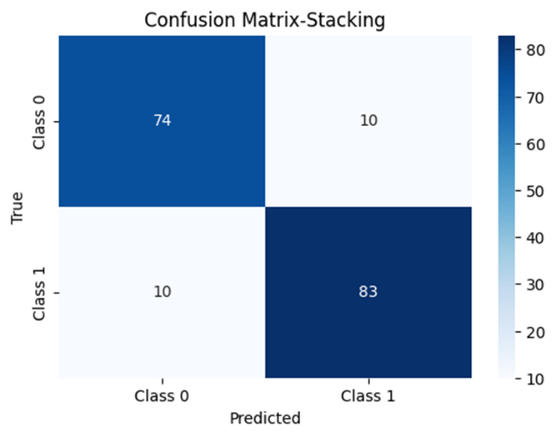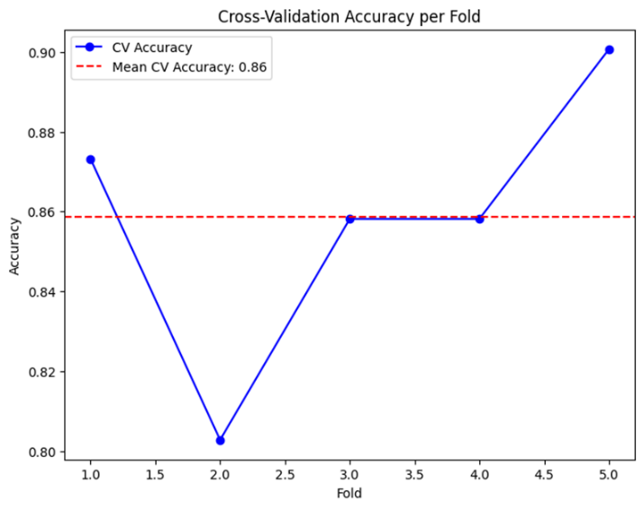

Fig. 7. Confusion Matrix of Stacking Model

Fig. 6. Cross-validation per field of Stacking Model

1. **XGBoost:** It was slightly lower but well worked with an accuracy of 0.88. XGBoost is an algorithm that uses bagging to help train multiple decision trees and combine all results.
2. **AdaBoost:** AdaBoost achieved good accuracy but did not perform as well as Stacking and XGBoost. The accuracy is 0.84, which is good. This type of statistical classification meta-algorithm works by weighting incorrectly classified instances more heavily.
3. **Random Forest:** RF is a combination of decision trees where every tree is developed with a specific random noise. Here, RF has a reasonable accuracy of 0.71 but is lower than the top three models, which is good but can not be the best classification model.
4. **GRU:** The Gated Recurrent Unit (GRU) is a type of Recurrent Neural Network (RNN). Having a low accuracy, GRU can not be the best model. Accuracy is 0.47 which is lower than other models. GRU uses less memory.
5. **LSTM and Bi-LSTM:** LSTM is long short-term memory and uses ANN, which also developed a low accuracy of 0.47, while Bi-LSTM got the same accuracy of 0.47. They also have lower performance in all metrics. They are not suitable for this dataset.
6. **SVM:** Support Vector Machine (SVM) performs moderately with lower accuracy and other metrics. SVM developed a medium accuracy of 0.53
7. **LIME XAI:** LIME (Local Interpretable Model-agnostic Explanations), a part of the Explainable Artificial Intelligence (XAI) field. It also had a low accuracy of 0.47, and the scores for other metrics needed to improve.

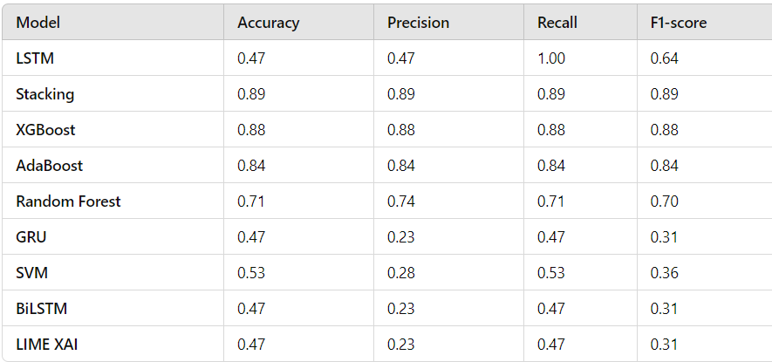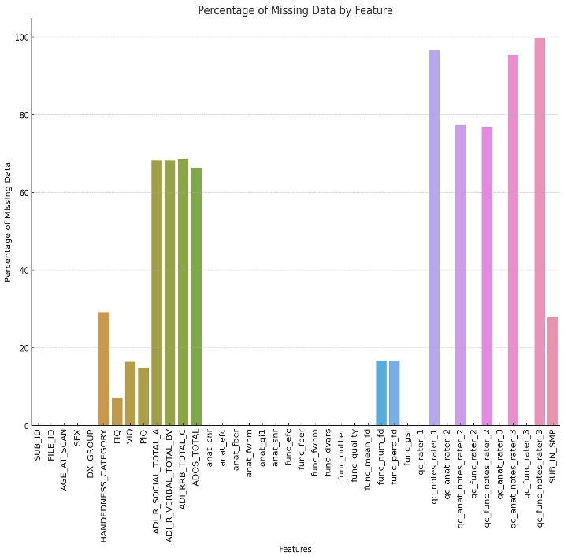

Fig. 8. Graphical representation of percentage data missing of particular features

Table **II**   
Accuracy, precision, recall, f1 score of different models using phenotypical data

## Limitations and Future Work:

* + - 1. **Data Limitations:** The study was limited to the SDSU subset of the ABIDE dataset due to computational constraints, affecting the sample size and potentially the generalizability of the results. Future studies should include larger and more diverse datasets to validate these findings.
      2. **Model Tuning:** Further hyperparameter tuning for models like SVM and BLSTM could improve their performance. Exploring different kernels for SVM and optimizing the architecture of neural networks could yield better results.
      3. **Feature Extraction:** While EfficientNet provided useful features, integrating additional feature extraction methods, such as other neural network architectures or combining GAF with other transformation techniques, could enhance model performance.
      4. **Combining Multi-Modal Data:** Incorporating non-imaging data, such as genetic, behavioral, and environmental factors, with fMRI data could provide a more comprehensive understanding and improve model performance. Environmental factors, with fMRI data, could provide a more comprehensive feature set, potentially improving classification accuracy.

# **Conclusion**

In conclusion, our hybrid approach combines the local feature learning capabilities of ResNet, and EfficientNet with the temporal and relational learning strengths of Bi-LSTM and Graph Neural Networks (GNNs), which provides a diverse framework for classifying brain disorders. This integrated method, which benefits both deep learning and graph-based techniques, aims to improve diagnostic accuracy and enhance the understanding of ASD biomarkers.

To achieve better accuracy and results, we plan to train our model using the entire ABIDE dataset, which will provide a more comprehensive and diverse set of data for learning and validation. By encompassing a larger dataset, we can improve the generalization and robustness of our model.

Our next step involves expanding our dataset by collecting fMRI and environmental data from various hospitals in Bangladesh. This will include not only neuroimaging data such as fMRI scans but also relevant environmental and possibly genetic information, which could include if there has been a history of ASD in the family. We will preprocess this data, converting it to time series formats suitable for analysis by our models.

Afterward, we will add additional models to this enriched dataset to train and test. This could include advanced neural network architectures, ensemble methods, and novel graph-based approaches to further refine our classification performance. By integrating these diverse data sources and advanced modeling techniques, we aim to develop a more accurate and reliable diagnostic tool for ASD, which can be expanded to more brain disorders like ADHD.

Further research will focus on:

Optimizing the parameters and architecture of our models to enhance their performance.

Applying various preprocessing and data augmentation methods to improve feature representation.

Combining neuroimaging data with other types of data, such as genetic, behavioral, and environmental factors, to provide a more holistic view of the disorder.

Conducting rigorous validation and testing using cross-validation and external datasets to ensure the reliability and robustness of our model.

By pursuing these avenues, we aim to develop a comprehensive diagnostic framework that improves classification accuracy and offers valuable insights into the underlying biomarkers of ASD and other brain disorders. This research has the potential to significantly enhance diagnostic practices and contribute to the early detection and treatment of these conditions.

# **References**

1. M. C. Lai, M. V. Lombardo, and S. B. Cohen, “Autism,” The Lancet, pp. 896-910, 2014.
2. M.G. Mosner, J.L. Kinard, J.S. Shah, S. McWeeny, R.K. Greene, S.C. Lowery, C.A. Mazefsky and G.S. Dichter, “Rates of Co-occurring Psychiatric Disorders in Autism Spectrum Disorder Using the Mini International Neuropsychiatric Interview,” Journal of Autism and Developmental Disorders, vol. 49, no. 9, pp. 3819–3832, 2019.
3. J.C. Harris, “The Diagnosis of Autism: From Kanner to DSM-III to DSM-5 and Beyond,” Journal of Autism and Developmental Disorders, 2021.
4. C. Lord, M. Rutter, P. C. DiLavore, and S. Risi, “Autism in DSM-5: Progress and Challenges,” Molecular Autism, 2021.
5. H. Zhang, D. Shen, and W. Lin, “Classification of Brain Disorders in rs-fMRI via Local-to-Global Graph Neural Networks,” IEEE Transactions on Medical Imaging, vol. 42, pp. 444-455, 2023.
6. M.H.Lee, M.M.M-Thomas, T.L. Benzinger, D.S. Marcus, C.D. Hacker, E.C. Leuthardt and J.S. Shimony, “Clinical Resting-state fMRI in the Preoperative Setting,” Topics in Magnetic Resonance Imaging, vol. 25, no. 1, pp. 11–18, 2016.
7. F. Almuqhim and F. Saeed, “ASD-GResTM: Deep Learning Framework for ASD classification using Gramian Angular Field,” in IEEE International Conference on Bioinformatics and Biomedicine, pp. 2837-2843, 2023.
8. H. Zhang, R. Song, L. Wang, L. Zhang, D. Wang, C. Wang, and W. Zhang, "Classification of Brain Disorders in rs-fMRI via Local-to-Global Graph Neural Networks," IEEE Transactions on Medical Imaging, vol. 42, no. 2, pp. 444-454, 2023.
9. D.C.E. Saputra, Y. Maulana, T. A. Win, R. Phann, and W. Caesarendra, “Implementation of Machine Learning and Deep Learning Models Based on Structural MRI for Identification of Autism Spectrum Disorder,” Jurnal Ilmiah Teknik Elektro Komputer dan Informatika (JITEKI), vol. 9, no. 2, pp. 307-318, 2023.
10. A. C. Koehler, M. S. Dong, A. M. Bierlich, S. Fischer, J. Späth, I. S. Plank, N. Koutsouleris, and C. M. Falter-Wagner, “Machine learning classification of autism spectrum disorder based on reciprocity in naturalistic social interactions,” IEEE Transactions on Affective Computing, 2024.
11. S. Barra, S.M. Carta, A. Corriga, A.S. Podd, and D. R. Recupero, "Deep Learning and Time Series-to-Image Encoding for Financial Forecasting," IEEE/CAA Journal of Automatica Sinica, May 2020

**Individual Contribution Table**

|  |  |  |
| --- | --- | --- |
| **Section** | **Contributing Member Name** |  |
| IEEE/LaTEX formatting | Sadman Israk Sporsho Md Zian Raian |  |
| Grammarly check | Md Zian Raian | Grammarly Score = 95 |
| Abstract | Naima Siddika Toha  Sadman Israk Sporsho |  |
| Keywords | Naima Siddika Toha |  |
| Introduction Motivation | Yuki Bhowmik Kazi Nafis |  |
| Paper Review 1 | Yuki Bhowmik | ASD-GResTM: Deep Learning Framework for ASD classification using Gramian Angular Field |
| Paper Review 2 | Sadman Israk Sporsho | Classification of Brain Disorders in rs-fMRI via Local-to-Global Graph Neural Networks |
| Paper Review 3 | Md Zian Raian | Implementation of Machine Learning and Deep Learning Models Based on Structural MRI for Identification of Autism Spectrum Disorder |
| Paper Review 4 | Naima Siddika Toha | Machine learning classification of autism spectrum disorder based on reciprocity in naturalistic social interactions |
| Paper Review 5 | Kazi Nafis | Deep learning and time series-to-image encoding for financial forecasting |
| Introduction Second-Last Paragraph | Sadman Israk Sporsho |  |
| Introduction Last Paragraph | Yuki Bhowmik |  |
| Proposed System | Yuki Bhowmik Sadman Israk Sporsho |  |
| Results and Discussion | Naima Siddika Toha Yuki Bhowmik Sadman Israk Sporsho |  |
| Figure title and format | Md Zian Raian  Naima Siddika Toha |  |
| Equations format | Md Zian Raian |  |
| Conclusions | Yuki Bhowmik Kazi Nafis |  |
| References Formatting in IEEE format | Md Zian Raian Kazi Nafis |  |